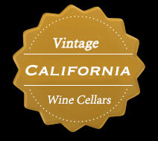

Wine Tasting Request Form

California Wine Cellars Inc.

Business Information
Account Name: | (New list) |  |  | License #:
Type of Business: |  |  | (Liquor Store, Restaurant, KTV/Bar, Others) | Date: |  | (select)
Contact Name:
Phone number:  Email address:  Address: |  |  | City: State: Zip Code :

Requests

Proposed date(s) of tasting event

- First desired date: (select)

- Second desired date: (select)

Proposed time of tasting event
- First desired time:

From: To: (select)

- Second desired time:

From: To: (select)

* Our promotions are usually three hours long but, we would like to add more under your request.

We have a list of outstanding California wines. Tell us which one or more you want for this tasting.
(typing )

What is expected of this tasting event?

Comments and Additional Requests

We hope our customers have an excellent experience, please let us know if you have any special request.

Additional Comments:

Requests:

